THE TITLE OF THE MANUSCRIPT SHOULD BE WRITTEN IN BOLD CAPITAL LETTERS (CALIBRI, font size 14, center)

First Author (Name and Surname)^{1*}, Second Author², Third Author³, …
(CALIBRI, bold, font size 12, center)

¹ Affiliation of first author, city, country
² Affiliation of second author, city, country
³ List all distinct authors in the same way

Abstract (CALIBRI, bold, font size 11)

The Abstract should not exceed 300 words, should state the principal objectives and the scope of the investigation, the methodology used, summarized results and principal conclusions. It should be typed in CALIBRI, font size 11, single-spaced.

Keywords: a list of up to 5 key words (3 to 5) (CALIBRI, italic, font size 11)

Corresponding author (e-mail address): e-mail

INTRODUCTION (CALIBRI, bold, font size 12)

Two lines below the Corresponding author begin the introduction. Use CALIBRI, font size 12, Justify alignment, single-spaced. Use italic for emphasizing a word or phrase. Do not use boldface typing or capital letters except for section headings.
The paper should be written in English*, using Microsoft® Office Word 2003 or higher, with a filename: Full Name of the First Author_IFC2020.doc.
All margins are 2.5 cm. Do not put number on the pages. If authors should use tables or figures from other Publications, they must ask the corresponding publishers to grant them the right to publish this material in their paper. References should be cited at the appropriate place in the text by consecutive Arabic numerals in square brackets and arranging the reference list at the end of the text.

MATERIALS AND METHODS (CALIBRI, bold, font size 12)

This section describes the available data and procedure of work and therefore provides enough information to allow the interpretation of the results, obtained by the used methods.

RESULTS AND DISCUSSION (CALIBRI, bold, font size 12)

Figures and tables should be incorporated in the text at the appropriate place and should fit on one page. Figures should be in high quality suitable for reproduction and print. Place them centered. Figures must be cited in consecutive numerical order in the text and referred to in both the text and in caption as: Figure 1, Figure 2, etc. Caption should be below figure, in CALIBRI, font size 12, centered.

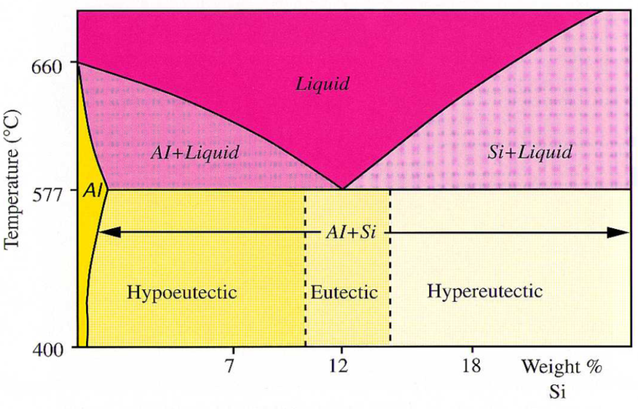
Figure 1. Phase diagram of Al-Si system

Tables must be cited in consecutive numerical order in the text and referred to in both the text and the caption as: Table 1, Table 2, etc. Place them centered. Caption of table should be above the table, in CALIBRI, font size 12, centered. Break larger tables into smaller parts to prevent extending over more than one page.

Table 1. Caption of table

Equations must be written by equation editor, centered and numbered consecutively, from 1 upwards, in rounded brackets.

(1)

CONCLUSIONS (CALIBRI, bold, font size 12)

This paragraph summarizes the results and draws conclusions.

Acknowledgements (CALIBRI, bold, font size 12)

This work was supported by the ****.

REFERENCES (CALIBRI, bold, font size 12)

References should be listed at the end of the paper as they appear in the text. References are cited in the text just by square brackets [1]. Two or more references at a time may be put in one set of brackets [3, 4] or [5-8]. The references are to be numbered in the order in which they are cited in the text and are to be listed at the end of the contribution under a heading References. Use the following styles for journals, books, conference proceedings and internet sites, respectively:

  - A. Author, B. Author, C. Author, Article title, Journal, Volume(Year)Issue, pp.
  - A. Author, The name of the Book, Publisher, City, Year.
  - A. Author, Article title in conference proceedings, Proceedings of International Symposium of …, (Editor), Publisher, Date, Year, City, Country, pp.
  - D. Kopeliovich, Sand Casting, Accessible on Internet: http://www.substech.com /dokuwiki/doku.php?id=sand_casting, date.

